**PROJECT DESIGN PHASE – II**

**Technical Architecture:**

|  |  |
| --- | --- |
| **DATE** | **19 October 2022** |
| **TEAM ID** | **PNT2022TMID17578** |
| **PROJECT NAME** | **A Gesture - Based Tool for Sterile Browsing of Radiology Ideations Images** |
| **MAXIMUM MARKS** | **4 Marks** |

**Technical Architecture:**

**Table-1: Components & Technologies:** 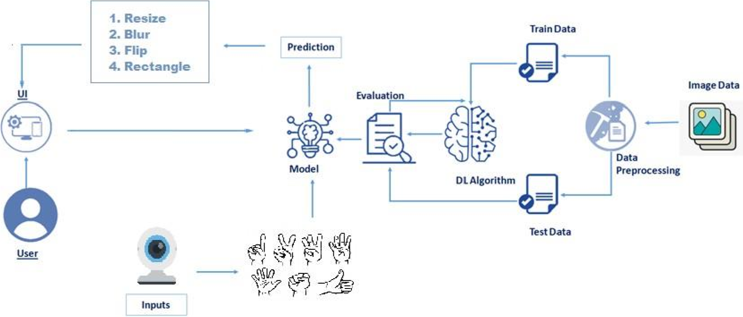

|  |  |  |  |
| --- | --- | --- | --- |
| **S.No** | **Component** | **Description** | **Technology** |
| 1. | User Interface | How user interacts with application e.g. Web UI, Mobile App, Chatbot etc. | HTML, CSS, JavaScript / Angular JS / React JS etc. |
| 2. | Application Logic- 1 | Variety of frameworks, libraries and  Supports are required to develop the project | Java / Python |
| 3. | Application Logic- 2 | Helps to convert the hand signs and hand gestures into the written words to surf on the internet and communicate with computer. | IBM Watson STT service |
| 4. | Application Logic- 3 | Provides fast, consistent and accurate answers after recognizing the human hand gestures and signs. | IBM Watson Assistant |
| 5. | Database | It can be numerical, categorical or time- series data | MySQL, NoSQL, etc. |
| 6. | Cloud Database | Enables the user to use host database without buying the additional hardware | IBM DB2, IBM Cloudant etc. |
| 7. | File Storage | File storage should be highly flexible, scalable, effective, fast and reliable. | IBM Block Storage or  Other Storage Service or Local Filesystem |
| 8. | External API-1 | Used to access the information in the cloud | IBM Weather API, etc. |
| 9. | External API-2 | Used to access the information for data driven decision making | Aadhar API, etc. |
| 10. | Machine Learning Model | Machine Learning Model deals with various algorithms that are needed for the implementation | Image Recognition  Model, etc. |
| 11. | Infrastructure (Server / Cloud) | Application Deployment on Local System /  Cloud  Local Server Configuration:  Install the windows version and execute the installer. | Local, Cloud Foundry, Kubernetes, etc. |

**Table-2: Application Characteristics:**

|  |  |  |  |
| --- | --- | --- | --- |
| **S.No** | **Characteristics** | **Description** | **Technology** |
| 1. | Open-Source Frameworks | The frameworks used in the project are | Tensor flow, Theano, RNN,  pyTorch, Flask |
| 2. | Security  Implementations | The security / access controls are implemented using  firewalls etc | Firewall and other security related software’s. |
| 3. | Scalable  Architecture | the scalability of architecture (3 – tier, Microservices) | Data, models, operate at size, speed, consistency and  complexity |
| 4. | Availability | the availability of application (e.g., use of load balancers, distributed servers etc.) | Image and facial recognition, speech recognition and real time captioning. |
| 5. | Performance | Design aspects for the performance of the application (number of requests per second, use of Cache, use of  CDN’s) etc | Full and effective participation, equality of opportunity, accessibility, using machine learning for communication. |